FORECASTING WEATHER RADAR PROPAGATION
CONDITIONS USING NWP MESOSCALE MODEL DATA

Joan Bech¹, Bernat Codina², Jeroni Lorente²
¹ Catalan Meteorological Service, C/ Berlin 38, 4, Barcelona 08021, jbech@meteocat.com, Tel. 34 93 5676090
² Dep. Astronomy and Meteorology, Barcelona University,
Av. Diagonal 647, Barcelona, 08028, Fax. 34 93 4021133

- Introduction

Quantitative use of weather radar observations, such as hydrological precipitation estimates or assimilation for NWP, require an exhaustive quality control system (see for example, Joss and Waldvogel, 1990; Alberoni et al., 2003). The electromagnetic propagation conditions of the troposphere may lead to anomalous propagation of the radar beam, so this factor may affect the quality of observations. In this work, done within the EU project CarpeDiem and in the framework of COST 717 WG2 (Frühwald, 2000), NWP mesoscale data is used to forecast the propagation environment in the Barcelona area (NE Spain). Four months of forecasts are compared with radiosonde observations.

- Weather radar propagation conditions

Variations of the air refractive index control the propagation conditions of the radar beam (Bean and Dutton, 1968). Standard conditions, i.e. –40 N units / km in the first 1000 m above ground level, are commonly assumed by weather radar processing software. However, departures from this value are not unusual and, in some places, show significant seasonal variations (Bech et al., 2000). For instance, under super refractive conditions the radar energy follows a lower trajectory than expected, increasing the quantity and intensity of spurious ground or sea clutter echoes (anaprop). This may affect post-processing procedures necessary for quantitative estimations such as topographic beam blockage corrections (Bech et al., 2003).

Two magnitudes have been considered to monitor the radar propagation environment: the vertical refractivity gradient (VRG) of the first 1000 m above ground level and a ducting index (I_{D}). The ducting index, which is adimensional, considers the degree of departure from the threshold of the super refractive gradient in the 3 first km of air, examining both surface and surface based microwave ducts and selecting the highest I_{D} calculated. Positive I_{D} values indicate superrefraction. Johnson et al. (1999) found a high correlation between this index and weather radar anomalous propagation echoes.
- NWP forecasts and radiosonde observations

The MASS model (Koch et al., 1985; Codina et al. 1997) was used to obtain vertical refractivity profiles from operational runs at 12 and 24 h. The version of the model was hydrostatic, with a horizontal grid resolution of 15 km and 30 vertical levels. The time period considered ranged from November 2002 to February 2003 allowing the comparison of 183 pairs of model forecasts and radiosonde observations collected in Barcelona (Figure 1).
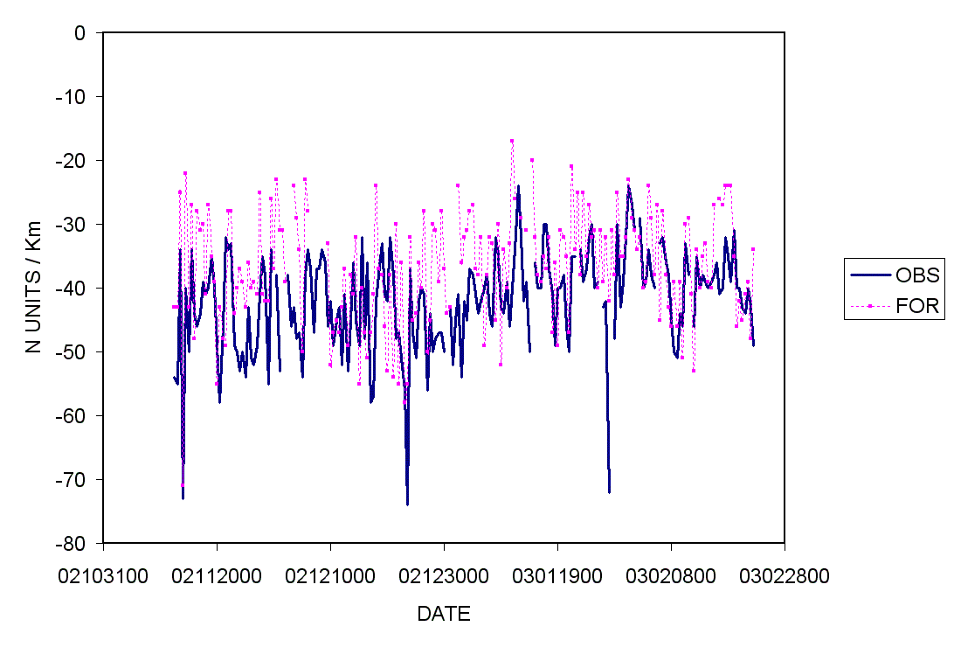
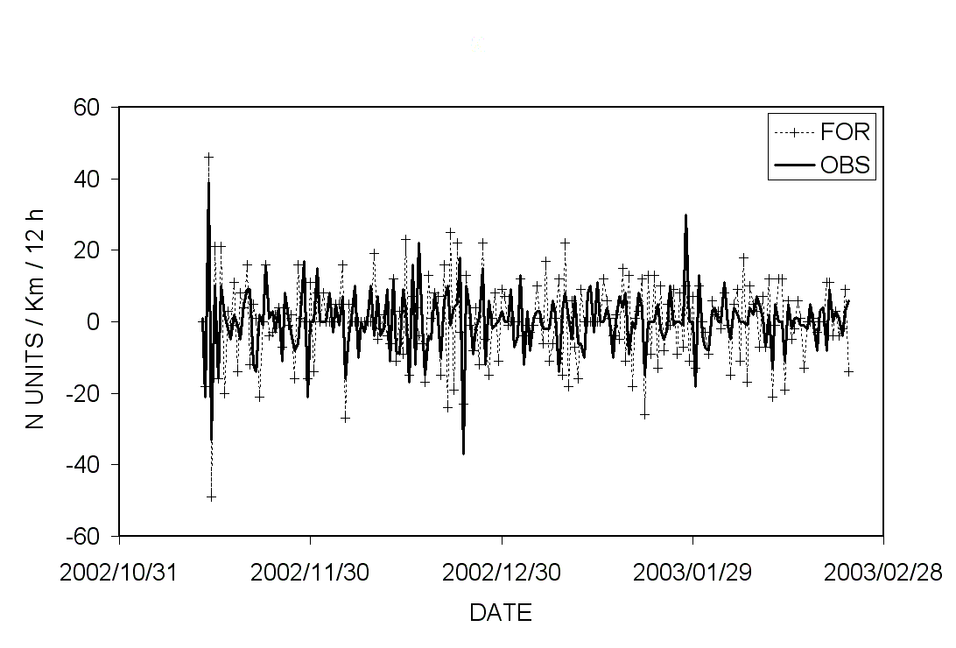
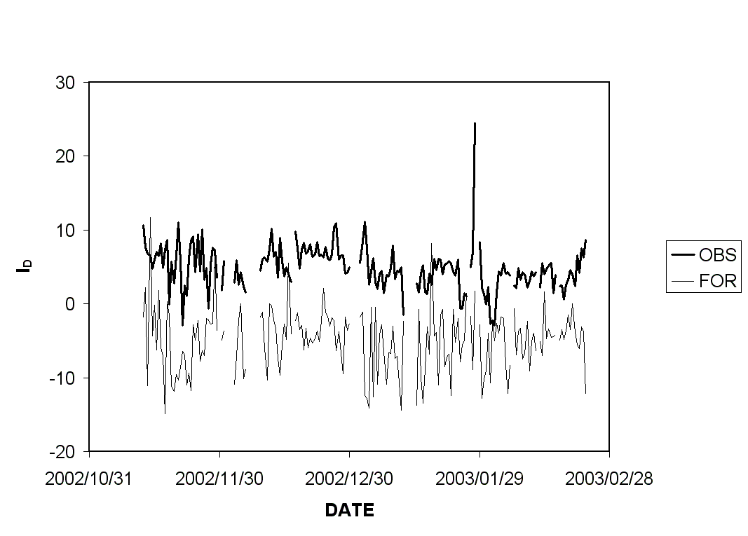
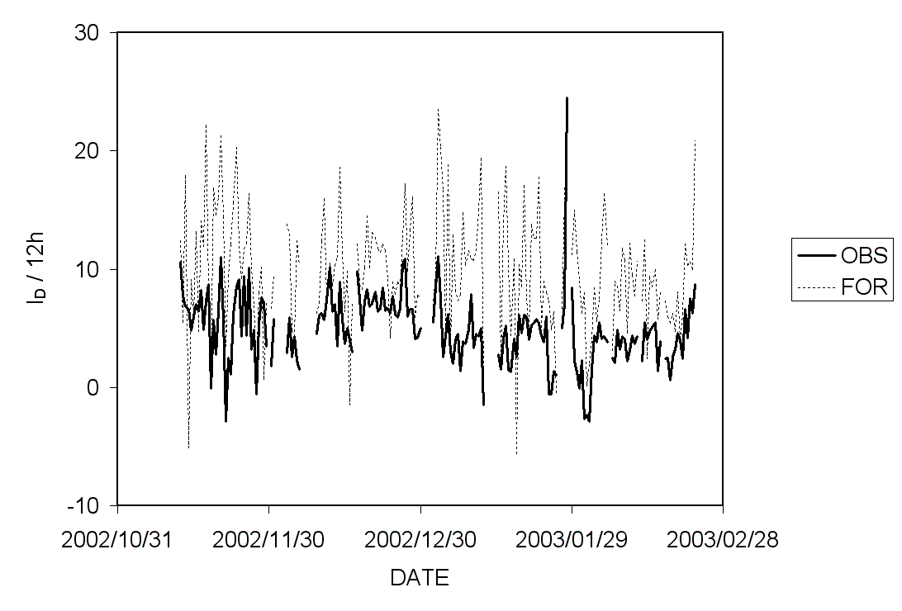
Fig. 1. Time series of VRG (left) and I_{D} (right) forecasts and observations (top) and the corresponding 12 h tendencies (bottom).
It may be appreciated that model forecasts tend to underestimate super refraction; both VRG and I_{D} are biased in this direction (5 N units/km and 10 I_{D} units, respectively). The mean absolute error were 8 units/km and 10 I_{D} units. The VRG 12 h tendency was generally in good agreement with the observations, particularly its sign, while I_{D} tendencies were sistematically greater than those observed. Time averaging with moving windows of 2, 7 and 15 days (not shown) indicated that average conditions and tendencies were reasonably well simulated by the model for VRG and, to a lesser extent, for I_{D} which presented more variability.

To compare these results with the persistence of the observations, their autocorrelation function, mean error (ME), mean absolute error (MAE) and root mean squared error (RMSE) up to 10 days were examined (Figure 2). For example, the lowest MAE for the VRG observations was achieved with the 12 h persitence (6,77 N units/km) and the ME with the 24 h persistence (0,09 N units/km). Similar results were obtained for the I_{D} persistence: 12h (–0.02 I_{D} units) and 36 h (2.31 I_{D} units) for the MAE and ME respectively. These values are better than those obtained with the model forecasts described earlier. So, taking into account these results, new modified forecasts were considered using both forecasts and previous observations.
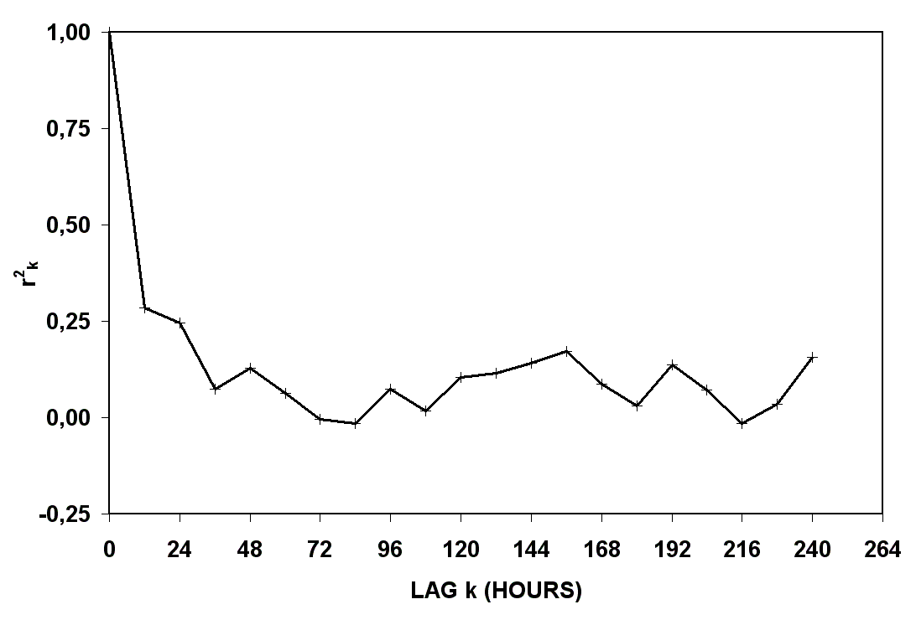
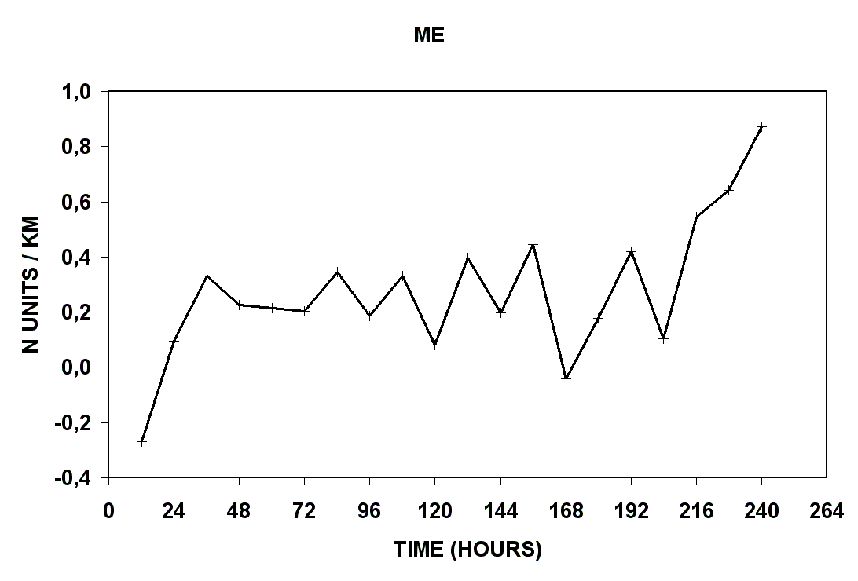
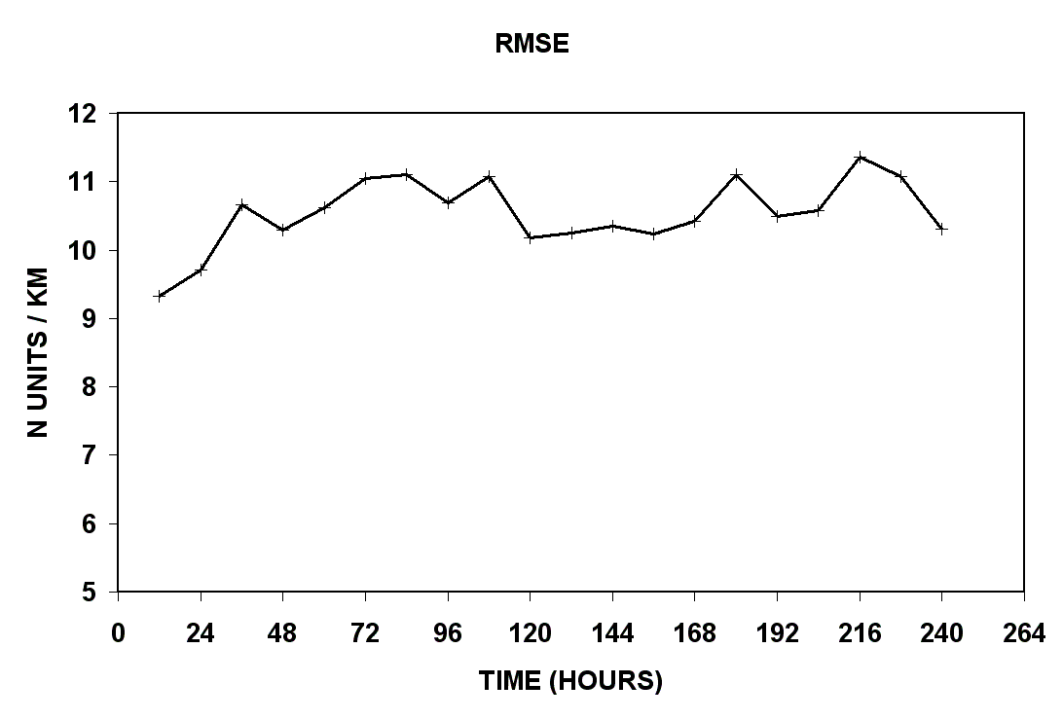
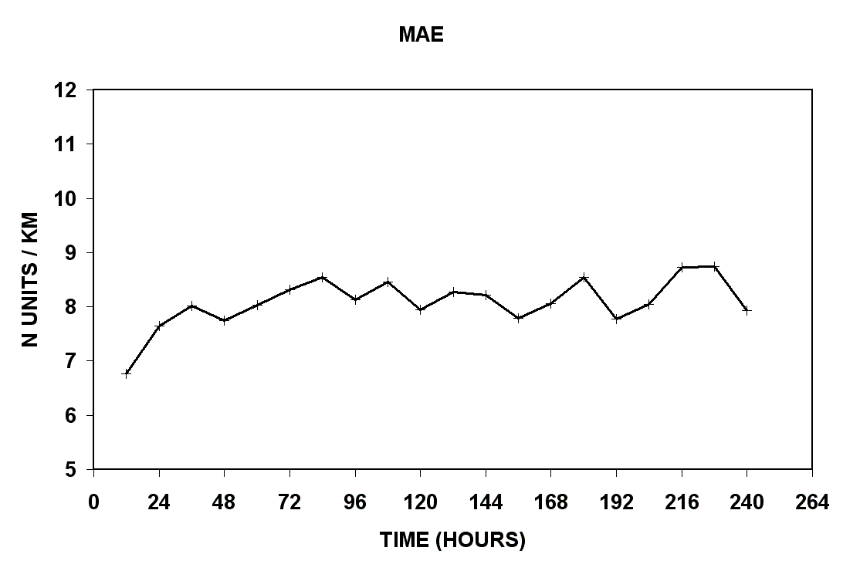
Fig. 2. Autocorrelation function (top left), MAE, ME, RMSE of VRG observations.

The modified forecasts, P´_{i}, were built considering simply an initial value P´_{i0} and an increment ΔP´_{i} :

P´_{i} = P´_{i0} + ΔP´_{i} .

Ten different P´_{i} , defined as a set of linear combinations of past observations (O_{i-1}, O_{i-2}, ... 12, 24 h old, etc) in the initial value P´_{i0} and forecasts (P_{i}, P_{i-1},...) in the increment ΔP´_{i} , were considered to introduce both the average state of the magnitude and the tendency. In this way, improved ME of 0.01 N units/km were achieved for the VRG. However the MAE did not decrease significantly respect the original VRG forecast. Similar improvements were obtained for the I_{D} forecasts.

On the other hand, a number of skill scores (Wilson, 2001) were considered to evaluate the ability of new I_{D} forecasts to predict a positive value of I_{D ,} (i.e., detection of super refraction) and were also compared with persistence of the observations 12 and 24 h. The result of the comparison pointed out that new forecasts improved significantly the original model forecasts (for example a POD of 0.89 in front of 0.84 for the unbiased model forecasts). However, the best scores were for I_{D} predictions were obtained using persistence at 12 h (POD: 0.96; FAR: 0.04).

- Summary and conclusions

NWP model data were used to derive refractivity profiles in order to estimate weather radar anomalous propagation conditions in the Barcelona area (NE Spain). In particular, the vertical refractivity gradient of the first km above ground level and a ducting index were calculated. Four months of model forecasts were verified with radiosonde observations. From this first comparison, and after examining the persistence of the observations, modified forecasts were tested. The new forecasts were built as linear combinations of previous observations and forecasts to improve both the average value and the tendency of original forecasts. Significant improvements were found with the new forecasts, in particular for the vertical refractivity gradient. However, radiosonde observations persistence at 12 h produced better skill scores when used to calculate the ducting index though both mean and mean absolute errors of new forecasts were better than those obtained with the original model output. Future work includes extending the data time period to cover all seasons and refining the modified forecasts by adjusting the average and tendency terms coefficients.

- References

Alberoni, P. P., V. Ducrocq, G. Gregoric, G. Haase, I. Holleman, M. Lindskog, B. Macpherson, M. Nuret, and A. Rossa, 2003: Quality and Assimilation of Radar Data for NWP — A Review. COST 717 document. ISBN 92-894-4842-3, 38 pp.
Bean, B. R., and E. J. Dutton, 1968: Radio meteorology. Dover Publications, 435 pp.
Bech, J., A. Sairouni, B. Codina, J. Lorente, and D. Bebbington, 2000: Weather radar anaprop conditions at a Mediterranean coastal site. Phys. Chem. of the Earth (B), 25, 829-832.
Bech, J., Codina B., Lorente J., Bebbington D., 2003: The sensitivity of single polarization weather radar beam blockage correction to variability in the vertical refractivity gradient. J. Atmos. and Oceanic Technol., 20, 845-855.
Codina, B., A. Sairouni, J. Bech, A. Redaño, 1997: Operational aplication of a nested mesoscale numerical model in Catalonia (Meteo'96 Project). INM/WMO International Symposium of Cyclones and Hazardous Weather in the Mediterranean, ISBN 84-7632-329-8, 657-667.
Frühwald, D., 2000: Using radar observations for parametrisations and validation of atmospheric models- strategy of COST 717 Working Group 2. Phys. Chem. Earth (B), 25, 1251–1253.
Johnson, C., D. Harrison, B. Golding, 1999: Use of atmospheric profile information in the identification of anaprop in weather radar images. Observation Based Products Technical Report No. 17, Forecasting Systems, UK Meteorological Office, 30 pp. [Available from the National Meteorological Library, London Road, Bracknell, RG12, 2SZ, UK]
Joss, J., and A. Waldvogel, 1990: Precipitation measurement and hydrology, a review. Radar in Meteorology, D. Atlas, Ed., American Meteorol. Soc., Boston, ed. D. Atlas, Chapter 29a, pp. 577-606.
Koch, S. E., W. C. Skillman, P. J. Kocin, P. J. Wetzel, K. F. Brill, D. A. Keyser, M. C. McCumber, 1985: Synoptic scale forecast skill and systematic errors in the MASS 2.0 model. Mon. Wea. Rev., 113, 1714-1737.
Wilson C., 2001: Review of current methods and tools for verification of numerical forecasts of precipitation. COST 717 Working Document WDF_02_200109_1, Met. Office, UK, 14 pp.

